[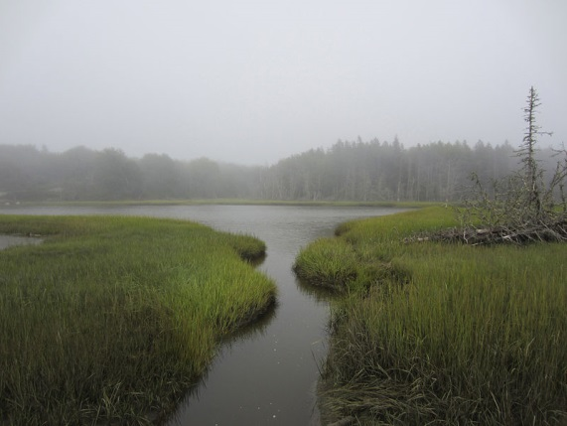](http://upload.wikimedia.org/wikipedia/commons/4/48/Pleasant_River_August_2012_Aviva_Rahmani.jpg)**Implications of the National Wetland Condition Assessment (NWCA) Report Findings for (State’s Name)**

**Did you know that (State Name)’s wetlands provide critical services that support our state’s economy?** Wetlands provide: *(Insert appropriate bullets here)*

* Contributions to flood control, clean water, groundwater recharge and other critical services
* Nurseries for the vast majority of our state’s commercial and sport fish species
* Critical habitat for (state name)’s game and hunting industry
* Natural resources relied on by the timber industry

These services can save taxpayers hundreds of millions of dollars as the result of water treatment facilities not having to clean more polluted water, from property damage from floods and storm surges or other expenses.

[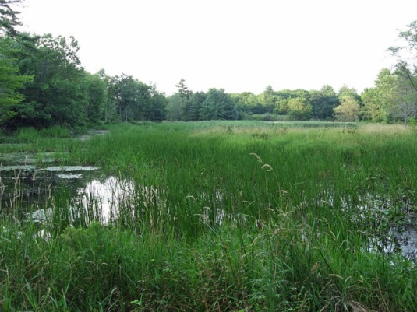](http://upload.wikimedia.org/wikipedia/commons/a/a8/Wetland_on_Marsh_Island.JPG)**What are Wetlands?**

*(Insert appropriate description here)*

Wetlands are part of the foundation of our nation's water resources and are vital to the health of waterways and communities that are downstream. Wetlands feed downstream waters, trap floodwaters, recharge groundwater supplies, remove pollution, and provide fish and wildlife habitat. Wetlands vary widely because of differences in soils, topography, climate, hydrology, water chemistry, vegetation, and other factors. (State name)’s wetlands include *salt marshes, peat bogs, fens*…add more here.

**What are the biggest threats to (State)’s Wetlands?**

*(Insert appropriate threats here)*

* Habitat fragmentation, development and poor land management practices
* Recreational and agricultural disturbances
* Storm surge and sea level rise
* Stormwater pollution
* Invasive species

**New EPA Report Assesses the Condition of Wetlands Nationwide:**

A new EPA Report Assesses the Condition Wetlands Nationwide. The U.S. Environmental Protection Agency released their most recent assessment of the condition of wetlands across the United State/Tribes on (date), called the *National Wetland Condition Assessment*. (NWCA).

**EPA National Aquatic Resource Surveys (NARS) are conducted every five years to evaluate changes in wetland condition over time**

|  |  |  |  |  |
| --- | --- | --- | --- | --- |
| 2007 | 2008 | 2009 | 2010 | **2011** |
| Lakes | Rivers | Wadeable Streams | Coastal Waters | **WETLANDS** |
|  |  |  |  | **→** |
| 2012 | 2013 | 2014 | 2015 | **2016** |
| Lakes | Rivers | Wadeable Streams | Coastal Waters | **WETLANDS** |

The NWCA is one of the five National Aquatic Resource Surveys initiated in 2006. These studies provide nationally-consistent and scientifically-defensible assessments of our lakes, rivers, wadable streams, coastal waters, and wetlands, and can be used to track changes over time. The purpose of the survey is to generate statistically-valid and environmentally relevant reports on the condition of the Nation’s wetlands.

Of the ____ sites nationwide, a total of __ wetland sites were selected by the EPA for assessment in (State/Tribe), including ___ (wetland type)s, ___ (wetland type)s and ___ (wetland type)s.

The NWCA study is the product of cooperation and collaboration between EPA, state officials and scientists. EPA provided the funding for the study and states provided the fieldwork and expertise to complete the assessment. To learn more about the NWCA or download the complete report, go to:

<https://www.epa.gov/national-aquatic-resource-surveys/nwca>

**The NWCA is being used to:**

* [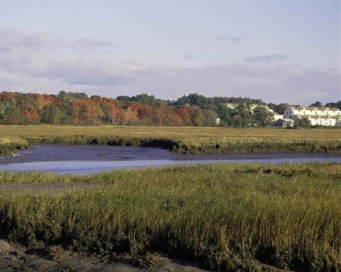](http://upload.wikimedia.org/wikipedia/commons/e/e0/Rachel_Carson_national_wildlife_refuge_maine.jpg)Determine the national & regional condition of wetlands (NWCA findings are not state-specific)
* Develop baseline information to evaluate change in wetland condition over time
* Build state and tribal capacity for monitoring and analyses

*It is important to note that results and findings from the NWCA are not being used by EPA or the state to provide State-level information or for regulatory purposes.*

**Key findings from the NWCA study include:**

*(Insert highlights from national report that are applicable to your state here)*

- Add here

- Add here

**How the NWCA relates to our state’s work to protect wetlands in (state name):**

*(Insert information about how report relates to known wetland condition in your state here)*

The EPA NWCA Projects’ objective is to assess wetland condition at the national and regional level, but not the state level. (*If your state is a state where an intensification was conducted, you can add this additional information*): To determine the condition of wetlands in our state, the EPA has funded a multi-year intensification study, which will be completed in 2016. Findings from this additional state -level statistical assessment of wetland condition suggests that (State/Tribe)’s wetlands are generally in a (similar/not similar) ecological condition to the findings of the NWCA. Our State/Tribe will also be conducting additional analysis of this data.

**What we need to accomplish in (State name) to better protect wetlands and their services:**

*(Insert appropriate goals here)*

* More public awareness of the value of (state)’s wetlands
* Better compliance with rules and regulations that protect wetlands
* Increased monitoring & assessment to target resources more effectively

**Actions we hope YOU will take to protect our state’s wetlands:**

*(Insert appropriate actions here – Examples of possible actions below)*

1. Support state laws and regulations that protect our state’s wetlands (Dredge and Fill Permitting, NPDES, etc.)
2. Lobby for funding support (example: Increase state funding for wetland monitoring and assessment)
3. Focus resources on habitat enhancement
4. Support X bill
5. Contact us if you have any questions or seek technical support about wetland issues
6. Consider wetland issues when you are working with others on flooding, pollution, storm surge and a variety of other extreme weather-related issues. ***Wetlands can play a critical role in reducing these impacts!***

**To learn more about what our state/tribe is doing to protect wetlands,** we encourage you to look at our state wetland program plan (insert web address to appropriate plan here). (State may want to list the core elements that they emphasize, e.g. regulation and monitoring and assessment).

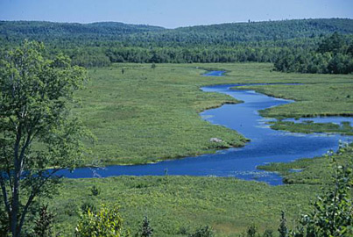

**Please Direct Questions about the NWCA Report and/or (state)’s wetlands to:**

**(State/Tribe) Wetland Program**

Primary Contact: Joe Wetlands, State/Tribal Coordinator Address: State Drive, City, State, Zip

Email: [jwetlands@state.gov](mailto:jwetlands@state.gov); Tel: (111) WET-LANDS